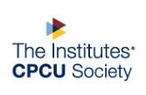
Agent and Broker Interest Group
Profile of an Agent
September 2019
JR Whitehead 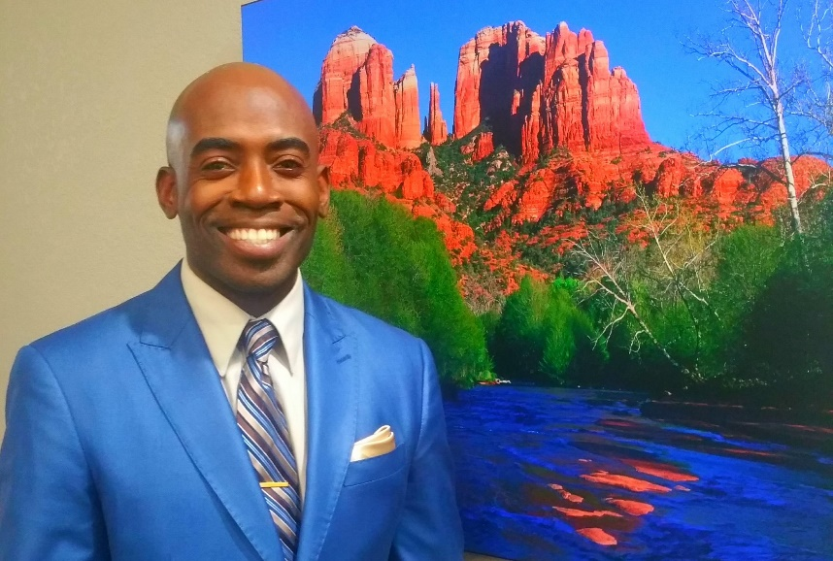
Director of Sales Arizona Region
Colorado Insurance
Years in Present Position: 1
Current role at CPCU Society: Treasurer
Alma Mater: The Institutes
Degrees and Certifications: AAI, AIM, CPCU

A & B: How did you come to work in the insurance industry?
A friend advised me that it would be a great career move since everybody needs insurance.

A & B: What is the most challenging aspect of your job?
Consistently staying current with all the vast changes with my 15 carriers and all the changes throughout the industry.

A & B: What aspect of your work as a broker do you find the most rewarding?
Educating our communities on the importance of risk management and developing leaders.

A & B: What emerging commercial risk most concerns you as a broker?
Autonomous vehicles and other technologies that could dramatically change the landscape of the industry.

A & B: What do you consider the most important short- and/or long-term issues facing the agent/broker community? Adapting quickly to new technology.

A & B: When & why did you become a volunteer leader at the CPCU Society?
I became a volunteer leader in the society in 2015, to stay current with the latest trends impacting our industry and to network with other great minds.

A & B: Has your involvement in the CPCU Society helped your career? If yes, explain.
Having the CPCU designation is one of the main reasons I’m in my current executive position now. My company understands the multiple benefits of the designation, and the dedication involved in obtaining it.

A & B: Who are your top 3 mentors? Why?
Napoleon Hill taught me the importance of having a positive mindset.
Walt Disney taught me how to maximize my imagination.
Delores Ramsey my mother taught me to always believe in myself and never give up.

A & B: What is your greatest accomplishment so far?
Being a parent is my greatest accomplishment!

A & B: What is your favorite book and/or movie?
Napoleon Hill’s Think and Grow Rich is my favorite book and The 5 Heartbeats is my favorite movie.

A & B: What is the most unusual/interesting place you have ever visited?
Punta Cana, Dominican Republic

A & B: How do you balance the responsibilities of yourself, family, work and CPCU?
Being a certified yoga teacher has taught me the priceless gifts of meditation and positive affirmations to help balance my multiple responsibilities.

A & B: What advice do you have for agents/brokers considering earning the CPCU Designation?
It would have a positive impact on your personal life and career! Start the journey NOW!

