Agent and Broker Interest Group
Profile of an Agent
May 2019

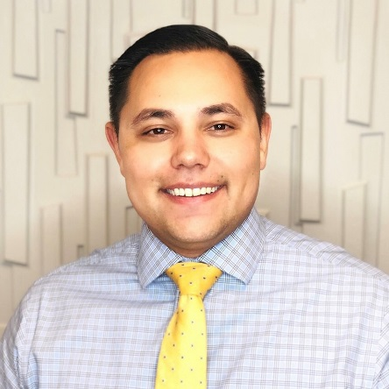
Hayden Threadgill
Sales Executive, Bouchard Insurance, A Marsh & McLennan Agency LLC Company
Years in Present Position: 2
Current role at CPCU Society: Chapter Secretary
Alma Mater: Florida State University
Degrees and Certifications: Bachelor’s Degree in History, CPCU, and ASLI

A & B: How did you come to work in the insurance industry? Like most people, I stumbled into the insurance industry after college. I planned on going to law school but eventually decided not to pursue that career. I started my insurance career at an MGA underwriting for Lloyds and other surplus lines insurance companies. I enjoyed that position but wanted the opportunity to be client facing. After three years, I moved into a sales position at Bouchard insurance in our select business unit. Currently, I am a sales executive in our large commercial department and could not be happier.

A & B: What is the most challenging aspect of your job? There are many challenges in a sales position regarding prospecting, etc. However, I find the biggest challenge is educating clients well enough for them to understand the difference between price and value regarding their insurance program. One of my favorite sayings is “The price is what you pay, but the value is what you get.”

A & B: What aspect of your work as a broker do you find the most rewarding? The most rewarding aspect of being a broker is protecting a business that my clients have worked so hard to build and that supports so many other lives. As an agent/broker I can act as a true consultant to protect my clients’ business assets.

A & B: What emerging commercial risk most concerns you as a broker? Data breaches and phishing attempts are becoming a real concern for businesses no matter what size. I believe that cyber liability insurance will need to be a staple in every business insurance program moving forward.

A & B: What do you consider the most important short- and/or long-term issues facing the agent/broker community? I believe both the short term and long-term issues facing agents/brokers are the same. There is a lack of younger producers within the insurance industry and the insufficient access to coverage training is even more of an issue. I believe this is an area where the CPCU can fill a gap for younger insurance professionals looking to grow their insurance knowledge.

A & B: When & why did you become a volunteer leader at the CPCU Society? Continual learning is a passion of mine. I believe the CPCU Society is a great platform to help individuals further their insurance knowledge and I wanted to be a part of that organization.

A & B: Has your involvement in the CPCU Society helped your career? If yes, explain. Yes, the CPCU society has introduced me to a network of insurance professionals that I would not have had the pleasure of interacting with if it had not been for this organization.

A & B: Who are your top 3 mentors? Why?
- John McManus – John was my past manager at Bouchard Insurance. He took the time to help hone not only my coverage skills but helped me apply those skills to further grow my book of business. He is one of the better technical insurance minds that I know and went out of his way to share this knowledge with me. With his help, I am a much better consultant for my clients.
- Michele Schrotter – Michele is our Agency Risk Manager at Bouchard Insurance and was one of the main reasons why I have volunteered at the CPCU society. Her passion for the CPCU society and for insurance in general is contagious. She also handles much of our initial producer training at Bouchard and has been a huge influence on many of our producers in this regard.
- Joe Rogan – He may not exactly meet the definition of a mentor as I have never met him in person, but Joe Rogan is an inspirational figure in my life. I listen to his podcast weekly and his work ethic along with his outlook on life inspire me to be the best that I can be.

A & B: What is your greatest accomplishment so far? One of my greatest accomplishments professionally has been earning the CPCU designation. I’m still early in my career as an agent so I’m excited for the opportunities it will bring.

A & B: What is your favorite book and/or movie? The 5 Second Rule by Mel Robbins is one of my favorite self-help books. The book is all about doing what you know you need to do and doing it now. It has helped me overcome some of the issues with procrastination that many of us face daily. I also highly recommend the book Fanatical Prospecting by Jeb Blount for any new sales representative/agent to the industry. This book has helped me open the door to many conversations with prospects.

A & B: What is the most unusual/interesting place you have ever visited? I haven’t been to many unusual places, but I did go on our sales trip to Costa Rica this year which was amazing.

A & B: How do you balance the responsibilities of yourself, family, work and CPCU? I try to plan my upcoming weeks on Fridays. This allows me to be as efficient as possible with work so that I have time for myself and family. I believe that work tends to expand or contract to the amount of time we give it so being diligent in blocking specific times for certain tasks and having goals for the week helps me to accomplish things more efficiently.

A & B: What advice do you have for agents/brokers considering earning the CPCU Designation? My advice is not to wait and to get started as soon as possible. The process in earning the designation is going to be challenging but the sooner you get started the more opportunities you will have to grow your book of business. I personally believe that agents/brokers that hold the CPCU designation are in a much better position to win and retain business as they can be a true consultant to their clients.

