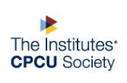
Agent and Broker Interest Group
Profile of an Agent
June 2019

Gabriela Dominguez 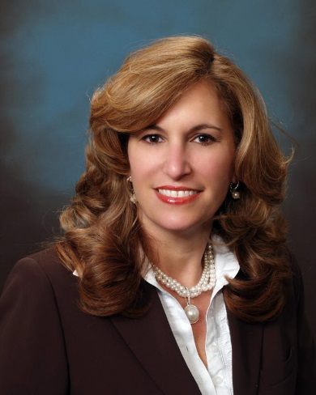
Agency Principal, Avante Insurance Agency Inc.
Years in Present Position: 36
Current role at CPCU Society: Leadership Council member at large
Degrees and Certifications: AA in Computer Science and CPCU

A & B: How did you come to work in the insurance industry? I came into the industry 33 years ago to assist my parents in automating their independent insurance agency operations. Prior to my coming in they did everything manually.

A & B: What is the most challenging aspect of your job? In today’s Florida market claims processing and handling claims adjuster interpretation of coverage, exclusions, etc.

A & B: What aspect of your work as a broker do you find the most rewarding? Meeting a new prospect and learning about their business and being able to provide them with a solution of products lines that will protect their business. I love the adrenaline of closing new business!

A & B: What emerging commercial risk most concerns you as a broker? Cyber Liability and Employment Practices Liability.

A & B: What do you consider the most important short- and/or long-term issues facing the agent/broker community? In the South Florida area: market availability, restrictions in coverages and affordability.

A & B: When & why did you become a volunteer leader at the CPCU Society? As soon as I received my designation, I became involved at the local chapter thanks to the President at the time Sherry Levin Rodriguez. After that I served on the Diversity Committee, as Regional Governor, and as Leadership Council member at large. I have attended most all Leadership Summits and Annual meetings and I find tremendous value and great takeaways in the programs they offer, and the people I have met through the years.

A & B: Has your involvement in the CPCU Society helped your career? If yes, explain. Yes, it has enhanced my professional skill as a Leader, it has set me apart within the industry as a knowledgeable professional.

A & B: Who are your top 3 mentors? Why? In my CPCU Journey Rudy Valdes Diaz, Sherri Levin Rodriguez, and Mike Koscielny. In my industry as a whole my parents.

A & B: What is your greatest accomplishment so far? Attaining the CPCU Designation.

A & B: What is your favorite book and/or movie? The Notebook by Nicholas Spark

A & B: What is the most unusual/interesting place you have ever visited? Cinque Terre is a series of villages clinging to a remote stretch of the Riviera coastline in Italy.

A & B: How do you balance the responsibilities of yourself, family, work and CPCU? I have been able to balance and joggle all of my responsibilities by applying discipline and commitment to my every day life.

A & B: What advice do you have for agents/brokers considering earning the CPCU Designation? I encourage all agents and brokers to first pursue the designation and then to get involved. Involvement is where you receive the wealth of knowledge, Leadership Training and ability to meet incredible individuals in this journey. All attributes that will make you a much better professional and set you apart within the insurance industry.

<

